**Computer Architecture Assignment 1**

**By: Christien Soosaipillai and Agilan Ampigaipathar**

Part 1

1.

|  |  |  |  |  |  |  |
| --- | --- | --- | --- | --- | --- | --- |
| A1 | A0 | B1 | B0 | L (A < B) | G (A > B) | E (A = B) |
| 1 | 1 | 1 | 1 | 0 | 0 | 1 |
| 1 | 1 | 1 | 0 | 0 | 1 | 0 |
| 1 | 1 | 0 | 1 | 0 | 1 | 0 |
| 1 | 1 | 0 | 0 | 0 | 1 | 0 |
| 1 | 0 | 1 | 1 | 1 | 0 | 0 |
| 1 | 0 | 1 | 0 | 0 | 0 | 1 |
| 1 | 0 | 0 | 1 | 0 | 1 | 0 |
| 1 | 0 | 0 | 0 | 0 | 1 | 0 |
| 0 | 1 | 1 | 1 | 1 | 0 | 0 |
| 0 | 1 | 1 | 0 | 1 | 0 | 0 |
| 0 | 1 | 0 | 1 | 0 | 0 | 1 |
| 0 | 1 | 0 | 0 | 0 | 1 | 0 |
| 0 | 0 | 1 | 1 | 1 | 0 | 0 |
| 0 | 0 | 1 | 0 | 1 | 0 | 0 |
| 0 | 0 | 0 | 1 | 1 | 0 | 0 |
| 0 | 0 | 0 | 0 | 0 | 0 | 1 |

2.

L = A1A0’B1B0 + A1’A0B1B0 + A1’A0B1B0’ + A1A0B1’B0’ + A1’A0’B1B0’ + A1’A0’B1’B0

G = A1A0B1B0’ + A1A0B1’B0 + A1A0B1’B0’ + A1A0’B1’B0 + A1’A0B1B0 + A1’A0B1’B0’

E = A1A0B1B0 + A1A0’B1B0’ + A1’A0B1’B0 + A1’A0’B1’B0’

3. KMaps

|  |  |  |  |  |
| --- | --- | --- | --- | --- |
| (L) A1A0  B1B0 | 00 | 01 | 11 | 10 |
| 00 | 0 | 0 | 0 | 0 |
| 01 | 1 | 0 | 0 | 0 |
| 11 | 1 | 1 | 0 | 1 |
| 10 | 1 | 1 | 0 | 0 |

L = A1’A0B0 + A1’B0 + A0B1B0’

|  |  |  |  |  |
| --- | --- | --- | --- | --- |
| (G) A1A0  B1B0 | 00 | 01 | 11 | 10 |
| 00 | 0 | 1 | 1 | 1 |
| 01 | 0 | 0 | 1 | 1 |
| 11 | 0 | 0 | 0 | 0 |
| 10 | 0 | 0 | 1 | 0 |

G = A1B1’ + A0B1B0’ + A1A0B0’

|  |  |  |  |  |
| --- | --- | --- | --- | --- |
| (E) A1A0  B1B0 | 00 | 01 | 11 | 10 |
| 00 | 1 | 0 | 0 | 0 |
| 01 | 0 | 1 | 0 | 0 |
| 0 | 0 | 0 | 1 | 0 |
| 0 | 0 | 0 | 0 | 1 |

E = A1’A0’B1’B0’ + A1’A0B1’B0 +A1A0B1B0 + A1A0’B1B0’

4.

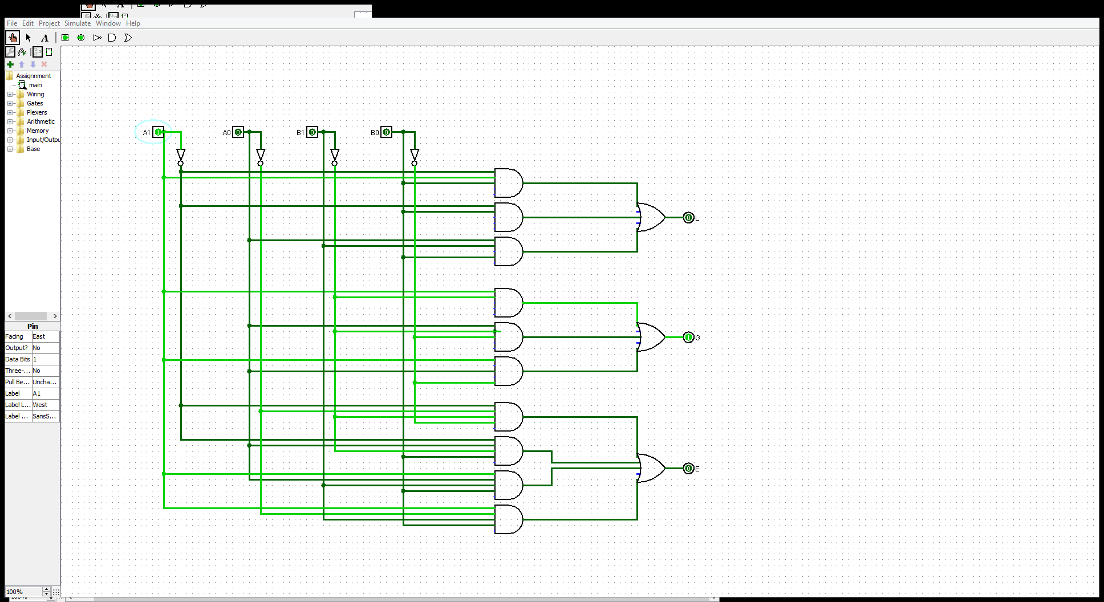

Part 2

1.

Three-Legged Race: Team B vs. Team J – Both Teams Need Both Their Respective Teammates to Cross Together in order to win the race

Even if one teammate from either team crosses the finish line alone before the other whole team cross together, the team that crosses together with both partners would win. If only one teammate from each team crosses, no team would win. If both teams cross the finish line together simultaneously then no team wins. If a team crosses the finish line with both teammates together with the other team not having any members cross the finish line, the team with both teammates that crossed the finish line would win. A trophy would have to be given if Team B wins or if Team J wins under the criteria mentioned above by equaling 1 under their respective winning column.

|  |  |  |  |  |  |  |  |
| --- | --- | --- | --- | --- | --- | --- | --- |
| Bill (Bi) | Bob (Bo) | John (Jo) | Jack (Ja) | BiBo | JoJa | Team B Wins (BiBo > JoJa) | Team J Wins (JoJa > BiBo) |
| 0 | 0 | 0 | 0 | 0 | 0 | 0 | 0 |
| 0 | 0 | 0 | 1 | 0 | 0 | 0 | 0 |
| 0 | 0 | 1 | 0 | 0 | 0 | 0 | 0 |
| 0 | 0 | 1 | 1 | 0 | 1 | 0 | 1 |
| 0 | 1 | 0 | 0 | 0 | 0 | 0 | 0 |
| 0 | 1 | 0 | 1 | 0 | 0 | 0 | 0 |
| 0 | 1 | 1 | 0 | 0 | 0 | 0 | 1 |
| 0 | 1 | 1 | 1 | 0 | 1 | 0 | 1 |
| 1 | 0 | 0 | 0 | 0 | 0 | 0 | 0 |
| 1 | 0 | 0 | 1 | 0 | 0 | 0 | 0 |
| 1 | 0 | 1 | 0 | 0 | 0 | 0 | 0 |
| 1 | 0 | 1 | 1 | 0 | 1 | 0 | 1 |
| 1 | 1 | 0 | 0 | 1 | 0 | 1 | 0 |
| 1 | 1 | 0 | 1 | 1 | 0 | 1 | 0 |
| 1 | 1 | 1 | 0 | 1 | 0 | 1 | 0 |
| 1 | 1 | 1 | 1 | 1 | 1 | 0 | 0 |

2.

Team B Wins (BiBo > JoJa) = BiBoJo’Ja’ + BiBoJo’Ja + BiBoJoJa’

Team J Wins (JoJa > BiBo) = Bi’Bo’JoJa + Bi’BoJoJa + BiBo’JoJa

3. KMaps

|  |  |  |  |  |
| --- | --- | --- | --- | --- |
| (Team B Wins (BiBo > JoJa)) JoJa  BiBo | 00 | 01 | 11 | 10 |
| 00 | 0 | 0 | 0 | 0 |
| 01 | 0 | 0 | 0 | 0 |
| 11 | 1 | 1 | 0 | 1 |
| 10 | 0 | 0 | 0 | 0 |

Team B Wins (BiBo > JoJa) = Jo’BiBo + Ja’BiBo

|  |  |  |  |  |
| --- | --- | --- | --- | --- |
| (Team J Wins (JoJa > BiBo)) JoJa  BiBo | 00 | 01 | 11 | 10 |
| 00 | 0 | 0 | 1 | 0 |
| 01 | 0 | 0 | 1 | 0 |
| 11 | 0 | 0 | 0 | 0 |
| 10 | 0 | 0 | 1 | 0 |

Team J Wins (JoJa > BiBo) = JoJaBi’ + JoJaBo’

4.

